**Telescopic shock absorbers for automobile suspension damping — Specification**

#### Table of contents

1 Scope 1

2 Normative references 1

3 Terms and definitions 1

4 General requirements 3

4.1 Materials 3

4.2 Finish 3

4.3 Assembly 3

4.4 End mountings 3

4.5 Fitment 4

4.6 Inclination 4

4.7 Supplementary welding 4

5 Tests 4

5.1 Damping force 4

5.2 Endurance test 5

5.3 Weld pull test 8

6 Effect of temperature on damping characteristics 8

7 Marking 8

8 Packaging 8

9 Additional information 8

9.1 Dimensions as indicated in Figure 1. 8

Annex A (normative) or (informative) <Subject of Annex> 9

Bibliography 10

#### Foreword

The African Organization for Standardization (ARSO) is an African intergovernmental organization established by the United Nations Economic Commission for Africa (UNECA) and the Organization of African Unity (AU) in 1977. One of the fundamental mandates of ARSO is to develop and harmonize African Standards (ARS) for the purpose of enhancing Africa’s internal trading capacity, increase Africa’s product and service competitiveness globally and uplift the welfare of African communities. The work of preparing African Standards is normally carried out through ARSO technical committees. Each Member State interested in a subject for which a technical committee has been established has the right to be represented on that committee. International organizations, Regional Economic Communities (RECs), governmental and non-governmental organizations, in liaison with ARSO, also take part in the work.

ARSO Standards are drafted in accordance with the rules given in the ISO/IEC Directives, Part 2.

The main task of technical committees is to prepare ARSO Standards. Draft ARSO Standards adopted by the technical committees are circulated to the member bodies for voting. Publication as an ARSO Standard requires approval by at least 75 % of the member bodies casting a vote.

Attention is drawn to the possibility that some of the elements of this document may be the subject of patent rights. ARSO shall not be held responsible for identifying any or all such patent rights.

This African Standard was prepared by ARSO/TC 59, Automotive technology and engineering

© African Organisation for Standardisation 2024 — All rights reserved[1]*

ARSO Central Secretariat

International House 3rd Floor

P. O. Box 57363 — 00200 City Square

NAIROBI, KENYA

Tel. +254-20-2224561, +254-20-3311641, +254-20-3311608

E-mail: [arso@arso-oran.org](http://www.arso-oran.org/arso@arso-oran.org)

Web: [www.arso-oran.org](http://www.arso-oran.org)

|  |
| --- |
| **Copyright notice**  This ARSO document is copyright-protected by ARSO. While the reproduction of this document by participants in the ARSO standards development process is permitted without prior permission from ARSO, neither this document nor any extract from it may be reproduced, stored or transmitted in any form for any other purpose without prior written permission from ARSO.  Requests for permission to reproduce this document for the purpose of selling it should be addressed as shown below or to ARSO’s member body in the country of the requester:  © African Organisation for Standardisation 2024 — All rights reserved  ARSO Central Secretariat  International House 3rd Floor  P.O. Box 57363 — 00200 City Square  NAIROBI, KENYA  Tel: +254-20-2224561, +254-20-3311641, +254-20-3311608  E-mail: [arso@arso-oran.org](http://www.arso-oran.org/arso@arso-oran.org)  Web: [www.arso-oran.org](http://www.arso-oran.org)  Reproduction for sales purposes may be subject to royalty payments or a licensing agreement. Violators may be prosecuted. |

**Introduction**

Automobile suspension systems are essential components that ensure a smooth and comfortable ride while maintaining vehicle stability and control. Shock absorbers are critical elements of any suspension system and play a pivotal role in dampening vibrations and impacts, enhancing driver comfort and vehicle safety.

Telescopic shock absorbers have emerged as a popular choice for automotive suspension damping due to their versatility, efficiency, and adaptability to various road conditions. These shock absorbers, often known as "shocks" or "dampers," use hydraulic or pneumatic principles to absorb and dissipate kinetic energy produced by the vehicle's movement. Thus, it maximizes tire-to-road contact and reduces vehicle oscillation.

A comprehensive standard for telescopic shock absorbers is imperative to maintain consistent and reliable performance across the automotive industry. Such a standard will guide manufacturers, engineers, and regulatory bodies, ensuring these critical components' design, testing, and performance meet stringent quality and safety criteria.

The standard addresses critical aspects, including design specifications, material requirements, testing procedures, and performance criteria. By adhering to this standard, manufacturers can ensure that their products meet the highest levels of quality and performance, contributing to safer, more comfortable, and more reliable automotive suspension systems.

This document outlines the principles, specifications, and requirements for telescopic shock absorbers to enhance the overall driving experience, vehicle safety, and industry-wide performance consistency. The vision is that this standard will serve as a vital reference for the automotive industry, fostering advancements in suspension technology and ultimately benefitting drivers and passengers across the continent and the world at large.

## AFRICAN STANDARD

**Telescopic shock absorbers for automobile suspension damping — Specification**

1 Scope

This Draft African Standard specifies the general performance requirements and test methods for telescopic shock absorbers used in automobile suspension damping, not including struts and semi-struts.

2 Normative references

The following documents are referred to in the text in such a way that some or all of their content constitutes requirements of this document. For dated references, only the edition cited applies. For undated references, the latest edition of the referenced document (including any amendments) applies.

ISO 4020, *Road vehicles — Fuel filters for diesel engines — Test methods*

3 Terms and definitions

For the purpose of this standard the following definitions apply.

**3.1**

**sealed type shock absorbers**

those which are not permitted to be overhauled, as the shock absorber has to be cut or machined to take out the internal parts

**3.2**

**serviceable type shock absorbers**

those which can be opened by removing the top threaded cap

**3.3**

**double acting**

shock absorbers which damp the oscillations of a vehicle suspension in both the directions, damping action being different or equal in either direction depending on the individual application requirements

**3.4**

**single acting**

shock absorbers which damp the oscillations of a vehicle suspension in one direction

**3.5**

**compression stage**

stage in which the mountings of shock absorbers approach each other

**3.6**

**extension stage**

stage in which the mountings of shock absorbers move away from each other

**3.7**

**compressed length**

length between the mounting eyes (centre to centre distance) or centre of the plain portion of shank (in case of studs) or mounting eye and plain portion of shank (in case of eye and stud) of a shock absorber when it is compressed to the maximum (see Figure 1) (and shall be within a tolerance of 3 mm or subject to the original drawing of the vehicle manufacturer, whichever is less)

(Gil'mkhanov & Гильмханов, 2013)

**3.8**

**stroke**

difference between the extended length and the compressed length (effective maximum travel of the piston), see Figure 1

**3.9**

**port**

inside diameter of the cylinder of the shock absorber

**3.10**

**fitment dimensions**

required for mounting the shock absorber on the vehicle (according to the vehicle manufacturer's specification similar to A, B, C, D, in Figure 1)

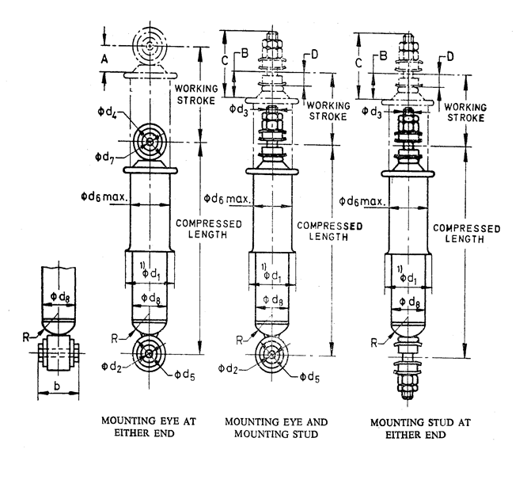

**Figure 1 — Fitment dimensions.**

**3.11**

**damping characteristics**

for any type of hydraulic shock, absorber, shall mean the damping forces at corresponding maximum piston velocity defined in 3.12

**3.12**

**maximum piston velocity**

subsequently referred to as “velocity”, shall be according to the vehicle manufacturer's specification or bear the relationship given by the expression:

*V* max   .*n* .*s*

where,

V max is the maximum piston velocity in metres/sec;

n is the machine revolution, Cps; and

s is the stroke in metres.

NOTE: n and s are derived from the endurance test of 5.2.

4 General requirements

4.1 Materials

Telescopic shock absorbers may be made from any suitable materials provided that the finished product shall pass the tests specified in Clause 5.

4.2 Finish

The piston shaft shall be uniformly hard chrome plated and be free from paint and other defects that may impair its assembly of performance. The exterior surface of the shock absorber shall be protected against corrosion.

4.3 Assembly

The shock absorbers shall be assembled in such a manner that the movement shall be smooth throughout the stroke. For this purpose, the shock absorbers shall be manually primed five times in a vertical position. This is only indicative of the uniformity of operation.

4.4 End mountings

Typical end mountings are shown in Figure 2.

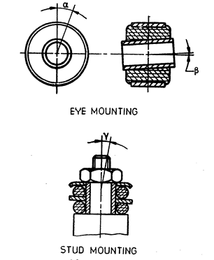

**Figure 2 — Typical mountings**

**4.4.1** When eye or stud mounting is used the maximum permissible deflection along the joint axis allowed during use shall be α = 5° maximum, or according to the manufacturer's specification.

**4.4.2** For the garden angle which is perpendicular to the joint axis the deflection shall be β = 3° maximum, or according to the vehicle manufacturer's specification, whichever is the less.

4.5 Fitment

The fitment of the shock absorber shall be governed by the top and bottom mountings of the vehicle or bars.

4.6 Inclination

Telescopic shock absorbers shall not be mounted at an inclination angle of more than 45° to the vertical plane of the chassis, unless otherwise specified by the vehicle manufacturer.

4.7 Supplementary welding

All eyes shall be supplementary welded to the caps to a maximum length of 10 mm.

5 Tests

5.1 Damping force

**5.1.1** Each shock absorber shall be tested along its own axis, that is, the damper axis parallel to the stroke of the torque tester.

**5.1.2** Damping forces shall be recorded between the sixth and tenth stroke.

**5.1.3** Test specification shall be only at one maximum piston velocity (or according to the vehicle manufacturer's specification).

**5.1.4** Tolerances on test damping force shall be ± 10 %.

**5.1.5** The arm of the application of damping force shall be selected at the discretion of the shock absorber manufacturer, provided that the specifications of the vehicle manufacturer shall be satisfied. In the case of preloaded shock absorbers, preloading shall be taken into account when performing this test.

**5.1.6** The effect of temperature as given in Clause 6 shall be applicable wherever necessary.

5.2 Endurance test

**5.2.1** The test shock absorber selected shall be mounted on the torque tester and the initial damping resistances in tension and compression shall be recorded.

**5.2.2** Shock absorbers whose initial damping resistances have been measured shall be mounted on the endurance testing machine. Testing speed shall be 104 ± 9 cpm or according to the vehicle manufacturer's specification, whichever is the less.

**5.2.3** During the test, temperature shall not exceed 85 °C, which shall be measured on the outer tube (reservoir) of shock absorbers. Where the temperature exceeds 85 °C, external cooling shall be applied to maintain the temperature at 80 °C ± 5 °C. In the case of shock absorbers where temperature does not rise above 85 °C, the test shall be carried at the temperature attained.

**5.2.4** The method of cooling during the endurance test is optional, but shall be such that any leakage of shock absorber fluid can be easily seen during the endurance test.

**5.2.5** Shock absorbers shall be mounted on a torque tester with flexible end mountings, only in the vertical plane.

**5.2.6** The test shall be conducted for one million cycles, but where vehicle manufacturer's specifications exist, they shall prevail. At the end of the test, no leakage or damage shall be noticeable; and the shock absorber when subjected to the damping force test as indicated in 5.1, variation in resistance shall not exceed the values indicated in Tables 1 and 2 (see also Figures 3 and 4) from the initial damping resistance recorded as in 5.2.1.

**Table 1 — Decrease in damping resistance after one million-cycle endurance test**

|  |  |  |  |  |  |  |  |  |  |  |  |
| --- | --- | --- | --- | --- | --- | --- | --- | --- | --- | --- | --- |
| **Damping resistance, newtons (N)** | | 500 | 600 | 700 | 800 | 900 | 1 000 | 1 100 | 1 200 | 1 300 | 1 400 |
| **Decrease in resistance** | Tension | 75 | 80 | 85 | 90 | 100 | 105 | 110 | 120 | 130 | 140 |
| Compression | 100 | 110 | 120 | 130 | 145 | 165 | 185 | 190 | 195 | 210 |

NOTE For damping resistances 1 200 N and above a decrease of 10 % is allowable in tension and compression, respectively.

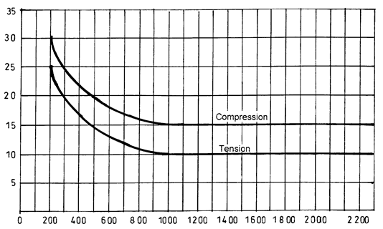

**Figure 3 — Decrease in damping resistance after one million cycle endurance test.**

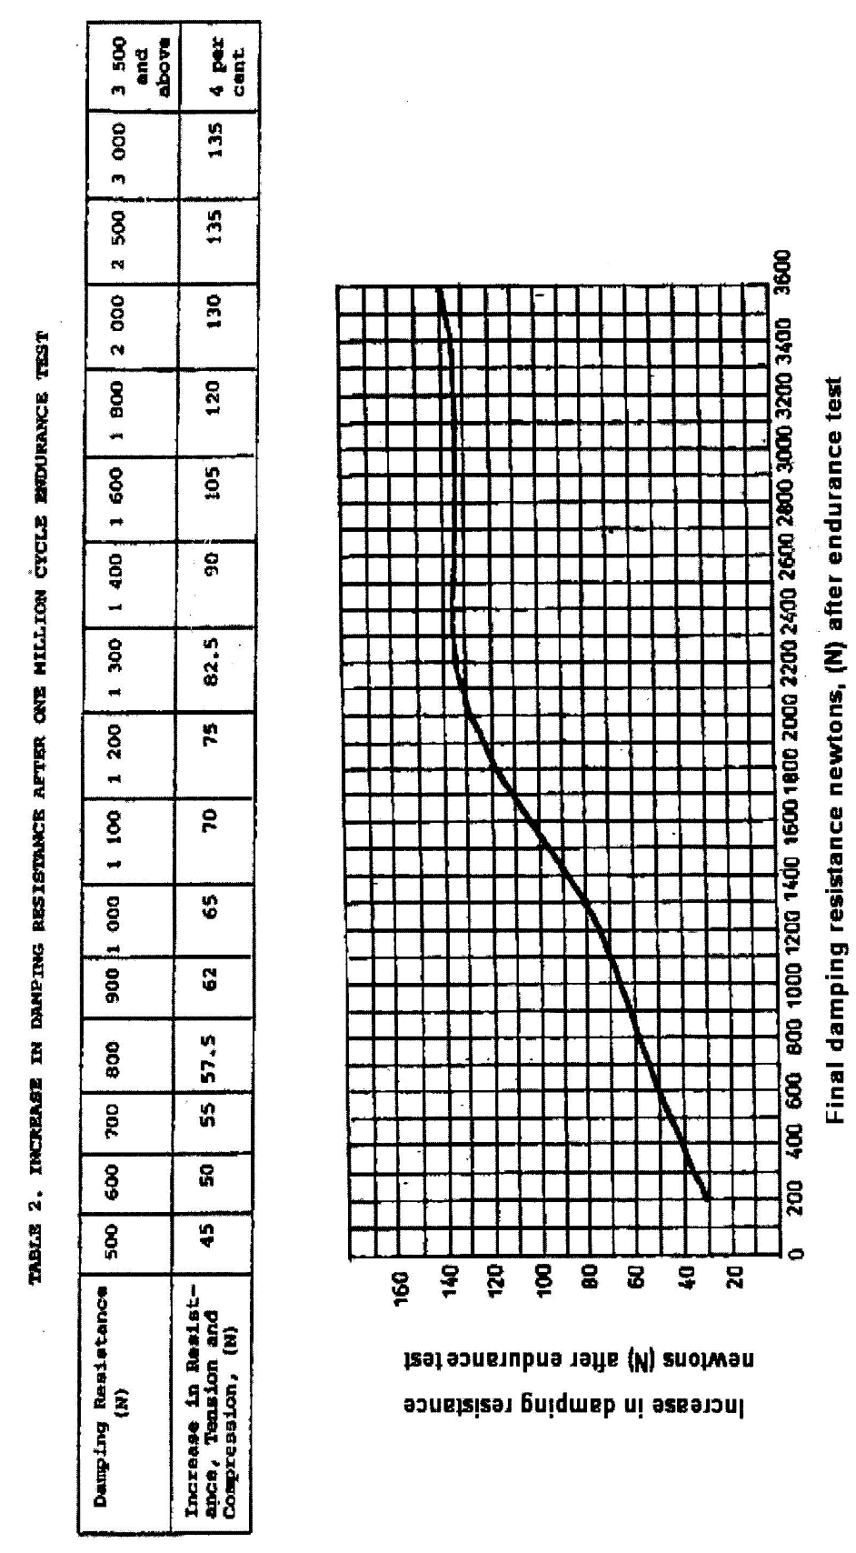

**Figure 4 — Increase in damping resistance after one million cycle endurance test**

5.3 Weld pull test

Telescopic shock absorbers, when subjected to weld pull tests, shall withstand the following forces:

1. small shock absorbers (up to 40 mm O.D.) 2.7 kN;
2. medium-duty shock absorbers (over 40 mm up to 50 mm O.D.) 3.6 kN;
3. heavy-duty shock absorbers (over 50 mm up to 65 mm O.D.) 4.5 kN; and
4. extra heavy-duty shock absorbers (over 65 mm O.D.) 5.4 kN.

6 Effect of temperature on damping characteristics

No temperature correction shall be applied if the test room temperature is within the range of 15 °C to 35 °C.

7 Marking

The shock absorbers shall be legibly and indelibly marked with the following:

1. manufacturer's name and/or trade mark;
2. country of origin;
3. year of manufacture; and
4. Part number (on body).

8 Packaging

Shock absorbers shall be packed in suitable cartons marked with the part number, or polythene packaging to allow the part number to be read on the product.

9 Additional information

The following information shall be supplied upon request:

9.1 Dimensions as indicated in Figure 1.

**9.1.1** A graph showing the load characteristics, in newtons, for compression and extension at various piston velocities; or alternatively load values for compression and extension at specified maximum piston velocity.

**9.1.2** Any other information relevant to the design of shock absorbers.

Annex A  
(normative) or (informative)  
  
<Subject of Annex>

<Text>

Bibliography

Working Group to identify and acknowledge useful literature used in the preparation of this standard

Gil'mkhanov, O. S., & Гильмханов, О. С. (2013). *Telescopic hydraulic shock absorber*. Retrieved 8 24, 2023, from https://patents.google.com/patent/wo2013151461a1/en

Liang, X.-C., & Zhao, J.-S. (2015). Research on recycling vibration energy of shock absorber. *International Journal of Vehicle Design, 68*. Retrieved 8 24, 2023, from https://inderscienceonline.com/doi/abs/10.1504/ijvd.2015.071079

1. * © 2024 ARSO — All rights of exploitation reserved worldwide for African Member States’ NSBs.